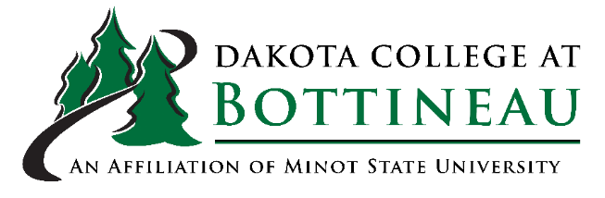

Nitrous Oxide/Oxygen Inhalation Analgesia Administration Course
12 CE Credits | 7 hours – home study – online assignments and textbook reading  2 hours – lecture  3 hours – clinical hands on – providing 3 inductions
Location | Dakota College Dental – Downtown Minot  OR  In your office
Cost | $350 per participant
Contact | Dakota College Bottineau  Rhonda Edwardson, M.Ed., RDH, CDA  701-858-3184  rhonda.edwardson@dakotacollege.edu or  dcbdentalclinic@dakotacollege.edu
Required textbook | Handbook of Nitrous Oxide and Oxygen Sedation  by Morris S. Clark, Ann L. Brunick.  6th Edition ISBN: 978-0-443-11335-2

